SAMPLE PAPER CLASS VIII
SOCIAL SCIENCE
TERM-I
Time: 3 Hrs Maximum Marks: 80
General Instructions:
- There are 28 questions in all.
- Marks for each question are indicated against it.
- All questions are compulsory.
- Question number 1 to 9 are very short answer questions of 1 mark each.
- Question from serial number 10 to 19 is of 3 marks. Answer of these should not exceed 80 words.
- Question from serial number 20 to 26 is of 5 marks. Answer of these should not exceed 120 words each.
- Question number 27 and 28 are map questions of 3 marks each from Geography and History. After completion, attach the maps inside your answer book.

1. According to scientific norms, what percentage of area of the world should be underforest to maintain ecological balance? 1
2. Define a National Park. 1
3. Name the author of the book “My Experiments with the Truth.” 1
4. In which language was the newspaper ‘Kesari’ published? 1
5. Name the system under which the revenue was directly collected from the cultivator? 1
6. Mention any Two provisions under Right to Equality. 1/2+1/2=1
7. Who occupies the most important position in the Parliamentary form of government. 1
8. What is Collective Responsibility? 1
9. Name the Two types of executives under Parliamentary form of government in India.
1/2+1/2=1
10. Explain the concept of Sustainable Development. Suggest any Two ways of achieving the objective of Sustainable development. 1+2=3
11. Mention any Three factors on which the utilization of resources depend. 3
12. Compare the important features of Tropical Evergreen Forest with that of Tropical Deciduous Forest. 3
OR
How are the trees of Mediterranean forest able to retain moisture during dry summer season?
13. “Deforestation in a rampant manner has depleted forest resources.” Suggest any Three measures to conserve them. 3
14. Describe the impact of British policies on the life of Tribals in India. 3
15. Enlist the important features of Zamindari System introduced by Lord Cornwallis in Bengal. 3
16. Explain the procedure of amending the Indian Constitution. 3
17. “The Directive Principles of State Policy are guidelines given by the Constitution.” List any Three of them. 3
18. Distinguish between Union List and the State List. 3
19. Describe the Composition of RajyaSabha, the council of States. 3
20. “Water is an indispensable resource.” Suggest any five ways to save this precious resource. 5
21. Why have large dams come under lot of criticism by the environmentalists? Give any five valid points. 5
22. Expalin any five events and consequences of Third Carnatic War. 2+3=5
OR
Describe the causes and consequences of Anglo-Sikh War.
23. Describe the steps taken by the British to suppress the revolt. 5
24. Mention the main causes of discontentment among the Indian Soldiers in the British army. 5
25. Enumerate the purposes which the Indian Constitution serves. 5
OR
Explain any five features of Indian Parliamentary form of government.
26. “The President is an integral part of Indian Parliament.” Justify the statement with reference to legislative powers of the President. 5
27. (1) Two features A and B are shown in the political map of the world. 3
Identify these features with the help of following information and write their correct names on the line marked on the map.
(A) A region of high rainfall area of Africa
(B) A type of forest

(2) On the same political map of the world, locate and label the following items with appropriate symbols.
(C) One region of Temperate Softwood Forest in Europe.
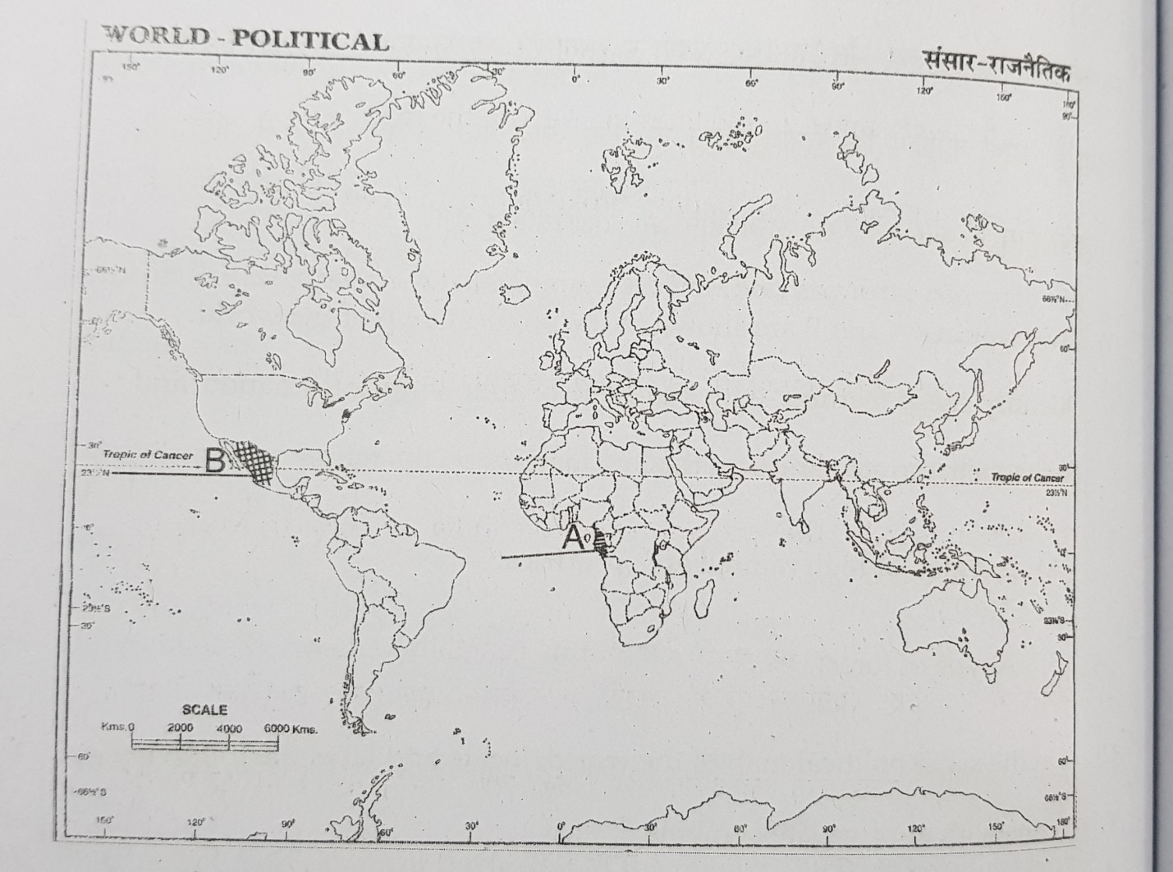

28. (1) two features A and B are shown in the political map of India. Identify these features with the help of following information and write their correct names on the line marked on the map.
(A) A place from where sepoys broke out in an open revolt.
(B) The place from where Rani Lakshmi Bai led the revolt of 1857
(2) On the same political map of India, locate and label the following place:
(C) Chhatisgarh- a present state of India to which Mundas belong.

